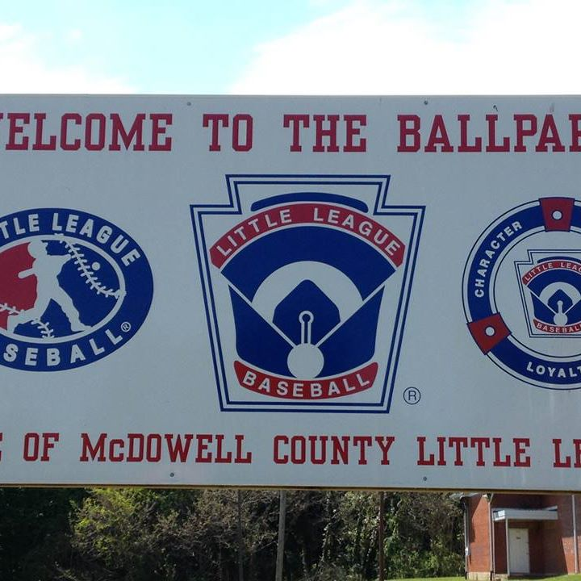
UNIFORM ORDER FORM
Parents,
Please fill out the form below to make sure your child is given a uniform that fits.
Thank You,
MCLL

Note: Shirts and pants come in------ Youth Large, Adult Small, Adult Medium, Adult Large

Name:________________________ Phone #__________________________

Shirt Size:__________________ Pant Size:_____________________

